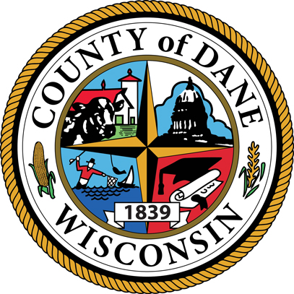

County of Dane Emergency Preparedness for Seniors
Presented by the Department of Emergency Management at Dane County
June 20, 2013

EXAMPLE TEMPLATE

Katie Freeman, Facilitator
County of Dane
xxx-xxx-xxxx
katie.freeman@xxxxxx.com

County of Dane Emergency Preparedness for Seniors
Slides | Your Notes
[insert information about the next module, if applicable]

For additional information about how you can prepare, or to find out how to get involved in preparing your community, contact:
Jason Ferguson, Coordinator
County of Dane
xxx-xxx-xxxx
jason.ferguson@xxxxxx.com

