June 3, 2015

Steven I. Berlin
Executive Director
Board of Ethics
740 North Sedgwick Street, Suite 500
Chicago, Illinois 60654

Dan Widawsky
Comptroller
Department of Finance
121 North LaSalle Street, 7th Floor
Chicago, Illinois 60602

Re: Gift of Office Space from Political Committee Accepted on Behalf of the City of Chicago

Dear Executive Director Berlin and Comptroller Widawsky:

This letter is to follow up on my prior letter regarding the gift of temporary office space for the 43rd Ward governmental office by the political committee Friends of Michele Smith, located at 2527 N. Lincoln, Unit E1. Pursuant to § 2-156-142(d)(8) of the Municipal Code of Chicago and 10 ILCS 5/9-8.10(c) of the Illinois Compiled Statutes, my government office accepted temporary office space for the following dates:

the week of April 20 through April 24, 2015;
the week of April 27 through May 1, 2015; and
the week of May 4 through May 8, 2015.

Based on the monthly rent paid for my political office, this came out to be a gift of $204.03, accepted on behalf of the City of Chicago.

Please let me know if there is anything more you need on this from my office.

Sincerely,
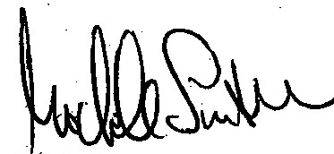
Michele Smith
Alderman, 43rd Ward

Enclosure: Prior letter on this matter dated April 17, 2015

two weeks at $68.75 and one week at $66.53

