From: Morita, Julie
Sent: Thursday, September 26, 2013 9:59 AM
To: Collazo, Ana
Subject: Gift

Hello Ana,
I presented at Trinity Hospital Grand Rounds yesterday. After speaking, the coordinator gave me a thank you card. Although I told the coordinator I was unable to accept gifts of any value, he included a $25 gift card for Starbucks in the thank you note. I did not realize the gift card was included until I returned to my office.

I have attached a copy of the letter I sent to the coordinator which included the gift card. I believe you need to have a copy for your files. Let me know if you need additional information.

Thank you,
Julie

Julie Morita, MD
Medical Director
Immunization Program
Chicago Department of Public Health

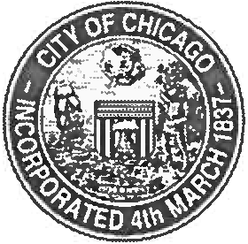

DEPARTMENT OF PUBLIC HEALTH

CITY OF CHICAGO

Charles H. Williams II, MPH Director, Medical Management Advocate Trinity Hospital
2320 E. 93rd Street
Chicago, Illinois 60617

September 26, 2013

Dear Charles,

Thank you for the opportunity to speak at your Grand Rounds on September 25,
2013. I also appreciate the Starbucks gift card that you gave to me. However, I
cannot accept gifts of any value.

I have enclosed the unused gift card. I appreciate your thoughtfulness and generosity. Your thank you note was more than sufficient.

Thank you again for the opportunity to speak with your staff.

Sincerely,

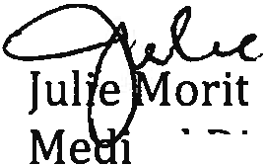yY)l)
a, MD

ca rector
Immunization Program
Chicago Department of Public Health

