April 17, 2015

Steven I. Berlin
Executive Director
Board of Ethics
740 North Sedgwick Street, Suite 500
Chicago, Illinois 60654

Dan Widawsky
Comptroller
Department of Finance
121 North LaSalle Street, 7th Floor
Chicago, Illinois 60602

Re: Gift of Office Space from Political Committee Accepted on Behalf of the City of Chicago

Dear Executive Director Berlin and Comptroller Widawsky:

This letter is to serve as notice of the following gifting to and acceptance on behalf of the City of Chicago, pursuant to §2-156-142(d)(8) of the Municipal Code of Chicago and 10 ILCS 5/9-8.10(c) of the Illinois Compiled Statutes:

The political committee Friends of Michele Smith has gifted office space, located at 2527 N. Lincoln, Unit E1, to the City of Chicago, for purposes of temporarily housing the 43rd Ward governmental office, which is undergoing rebuilding and renovations. Approximately 50% of my political office will be used by my governmental office, on a week-to-week basis. The monthly rent for my political office is $825 per month, making each week of use by my governmental office equivalent to $68.75 per week.

The remodeling of our governmental office will begin on Monday, April 20, 2015, and we anticipate the work to last two to three weeks. I will be sure to send a concluding letter to both of you indicating the end of this weekly gift.

Please let me know if there is anything more you need on this from my office.

Sincerely,
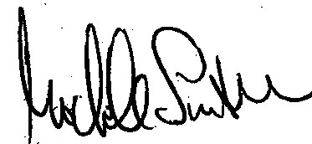
Michele Smith
Alderman, 43rd Ward

$825 x 50% / 30 days x 5 days a week = $68.75 per week

