From: Loretta Miller
Sent: Wednesday, May 16, 2018 11:36 AM
To: Steve Berlin
Subject: Re: Approval for Third-Party Travel and Lodging

Hi Steve, I apologize that I was a little late with this email I was out of the office for a week working on an off-site outbreak. I returned from the NEARS Users Meeting in Atlanta, GA on May 2, 2018. As previously stated, my lodging and travel expenses were provided by the National Association of County and City Health Officials (NACCHO). My meals and ground travel will be reimbursed also by NACCHO. Please see attached information as confirmation of who paid, when and where.

Thank you again for your approval and assistance!

Loretta Miller

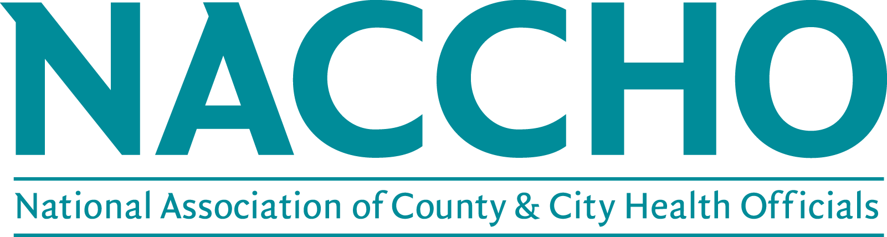

NEARS Users Meeting

Crowne Plaza Atlanta – Midtown Atlanta, GA

May 1st to May 2nd, 2018

Regulations About Reimbursable Expenses
As a national public health organization, NACCHO has need for people from all over the country to travel for NACCHO business. The following information is used to assist in obtaining reimbursement from NACCHO for travel expenses. Questions should be directed to Chandra M. Champion at cchampion@naccho.org or 202-507-4245.

Meals and Incidental Expenses
Items such as personal telephone calls and room service items (e.g., movies, bar) are considered personal expenses and will not be reimbursed.
Reimbursement will be made up to a maximum per diem of $71. This is designed to cover the cost of purchasing meals while traveling and to cover small incidental expenses such as non-meal tips. The $71 will be reduced by the cost of the meals which the traveler does not have to purchase while traveling. No per diem will be provided for any meal provided at the meeting. This restriction includes meals which are furnished by NACCHO and meals that do not need to be purchased because the traveler is not traveling at a time that a meal would occur.
The cost of meals and incidental expenses (M&IE) and lodging will be reimbursed as follows:
Activity | Date | Reimbursable amount
Meals & incidental expenses | April 30th | $32 for dinner, $6 for incidentals
 | May 1st | $71 per diem
 | May 2nd | $71 per diem
Lodging (room charge and tax) | April 30th - May 2nd , 2018 | Billed directly to NACCHO
Train or Airfare |  | Up to $700
Ground Transportation |  | Up to $200
Mileage (Can only be claimed if over 20 miles) |  | $0.545 per mile

Please claim per diem for the meals you purchased while on travel (i.e., you may not claim breakfast per diem if you did not start your travel until after the time regularly eat breakfast and you may not claim dinner per diem if you arrive home before you regularly eat dinner). Travelers who spend time traveling over and above what is needed for NACCHO business will not be reimbursed for per diems unless the extra time spent results in net savings to NACCHO.
How to Obtain Reimbursement

Complete the NACCHO Travel Expense Voucher. See Instructions below for more information on how to complete the form.

Attach ORIGINAL receipts for lodging, air, ground, and other related expenses for which reimbursement is being requested. These receipts should be taped to an 8½” by 11” sheet of paper (using multiple sheets if necessary). Receipts for per diem expenses are not required. Any purchase over $25 must be documented with an original receipt.

Submit Travel Expense Vouchers with corresponding receipts to NACCHO within 15 days after the travel has been completed. NACCHO will not reimburse vouchers received which are older than 30 days. The Vouchers should be sent to the project contact for approval and the project contact will forward them to the accounting department for payment. Payments will be made by the accounting department on a biweekly basis. Please note that following the above procedures will expedite the reimbursement process.

Traveler Information Section
Enter the name, phone and fax numbers, email, and mailing address for the traveler. This is the address to which reimbursement checks will be sent.

Dates of Trip
Enter the dates of the trip, from the beginning of the travel to the return. This is the duration of the travel being reimbursed by NACCHO.

Time of Departure and Time of Return
Indicate when the traveler departed for the trip and when the traveler returned from the trip. These times are used to calculate per diem expenses.

Description of Expenses Section
- Air/Rail. Enter the amount of air or rail tickets if purchased directly by the individual traveler. These expenses must be pre-approved for reimbursement by NACCHO staff prior to the trip. Include any service fee charged in this section.
- Taxi/Bus/Ground transportation. Enter the amount of ground transportation expenses. NACCHO encourages the use of shared-ride vans and shuttles to reduce travel expenses whenever possible. This includes subway fares and other public transport expenses.
- Garage Parking/Tolls. Enter amount of parking expenses and tolls.
- Personal Car Mileage. In the box marked “Personal car mileage” enter the total number of miles driven using personal vehicles. NACCHO will reimburse for these miles at the current allowable rate (Refer to the IRS website for the current mileage rate. The rate for the period January 1 – December 31, 2018 is $0.545 per mile. The rate is listed on the Travel Expense Voucher.). In the “From/ To” box indicate where the personal miles were accumulated (i.e., “Washington DC to BWI airport, BWI airport to NACCHO Office” or other description of departure and arrival points). Document of actual mileage is desirable (i.e., Yahoo! or MapQuest mileage totals) but not required.
- Hotel/Motel expenses. Enter allowable hotel or motel costs, or other costs of lodging.
- Phone/Telegrams/Fax. Enter expenses for allowed, business-related fax and phone costs. Travelers are permitted to call home once per day they are on travel for a reasonable amount of time.
- Per diem section. Enter the amount claimed for each meal that was not provided to you during the trip. Incidentals may be claimed for gratuities paid and other incidental expenses during your travel.
- Rental cars. Enter rental car expenses if approved prior to the trip by NACCHO staff.
- Other expenses. Enter the amount of other reimbursable expenses incurred and describe these expenses in the box provided on the form. If additional space is necessary, attach another sheet of paper.

Total Expenses
If the form is completed electronically, the total expenses will be calculated automatically. If the form is completed by hand, enter the total expenses for each row and column in the appropriate spaces provided. Double check the Total Expenses prior to submission.

Balance Due
Enter the amount due the traveler, or the amount due NACCHO, depending on the total expenses and advances received. This will be computed automatically if the form is completed electronically.

Traveler Signature
The traveler must sign and date the voucher to obtain reimbursement.

Contact for Questions

If you have any questions, please contact the NACCHO Meetings and Events Manager, Chandra M. Champion, at 202-507-4245 or cchampion@naccho.org.

