January 16, 2019

Via Email

Dear Steve,

Representatives of the National League of Cities (NLC) invited me, in my official capacity as Alderman of the 39th Ward and President Pro Tempore of the City Council, to join them at the Consumer Electronics Show, January 8-11, 2019, in Las Vegas, Nevada. The Consumer Electronics Show is our nation’s largest tradeshow hosting more than 180,000 industry attendees.
Other elected officials attending as members of the NLC delegation were Councilmember Joe Buscaino, City of Los Angeles, CA, Councilmember John Kinnaird, City of Waco, TX, and Councilmember Trevor Ozawa, City of Honolulu, HI. David Maloney, NLC Director of Strategic Partnerships and Development, was the agency’s representative.

I attended the event as a guest of the Consumer Technology Association. The Consumer Technology Association provided roundtrip coach airfare, lodging, transportation in Las Vegas from and to the airport, and group meals to the NLC delegation during our stay in Las Vegas. The delegation was also invited to participate in the Leaders in Technology program at the show.

Please let me know if you need any additional information.

Sincerely,

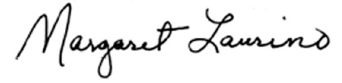

Margaret Laurino
Alderman, 39th Ward
President Pro Tempore, Chicago City Council

