From: Anne Emerson
Sent: Thursday, July 11, 2019 4:10 PM
To: Steve Berlin
Subject: Link to event

Hi Steve!

Thank you as ever for your time. My email is being weird so here is a link to the event information through which you can also access links to more information about Local Progress.

https://www.eventbrite.com/e/local-progress-national-convening-2019-tickets-57545595425
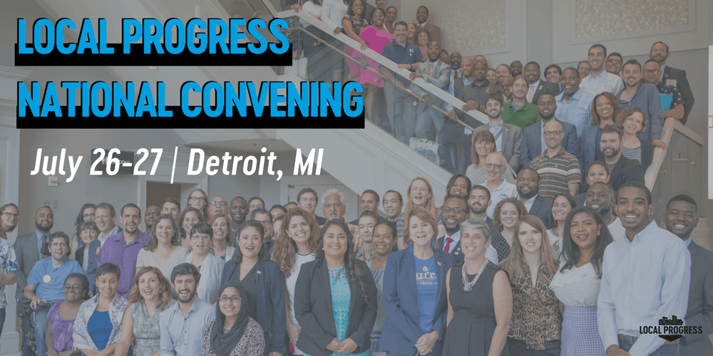 | Local Progress National Convening 2019 Tickets, Fri, Jul 26, 2019 at 8:00 AM | Eventbrite  www.eventbrite.com  Eventbrite - Local Progress presents Local Progress National Convening 2019 - Friday, July 26, 2019 | Saturday, July 27, 2019 at Detroit Marriott at the Renaissance Center, Detroit, MI. Find event and ticket information.

It is essentially a National Progressive Policy Nerd weekend that is focused on the municipal level.

Have a great evening!

Anne Weston Emerson
Chief of Staff
Committee on Finance

